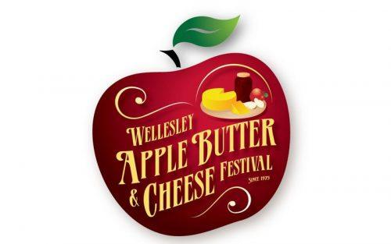

**Agenda**

Wellesley Apple Butter & Cheese Festival Committee

June 10th, 2025 – 7:30 p.m.

Bill Gies Recreation Complex – Active Living Centre Room 101 ***Please note the room change and enter from the outside door to the room located at the South/East corner of the building.***

1401 Queen’s Bush Rd, Wellesley

1. **Call to Order**:
2. **Disclosures of Pecuniary interest**:
3. **Adoption of Minutes**: Motion to adopt the minutes of the May 13th, 2025 meeting as printed:
4. **Presentations/Delegations/Communications:**

1. **Unfinished Business**:

*Food handler Certification. Cassandra Smyth has taken the course. Update on other training.

*Dance after the 2025 Festival. Bob Reid to report.

*Transition to new storage building. **Derek Brick** to report on discussions with the Township.

*Gateway Signs. Michael Fritz to report on progress and invoice, quote and pictures sent as attachments to agenda.

*4-H Petting Zoo. **Tim Leis** to give update.

*Replacement Picnic Tables. Did everyone get a chance to look at them? **Motion required for purchase.**

*Potential projects for Festival Funds:

Derek Brick requested a picnic shelter at the Bill Gies Recreation Complex. O/S until all commitments have been funded. *Update from the Township: 2 open sided shelters are being installed to provide shade. Perhaps consider a bandshell.*

White netting for the arena. Danny Roth to provide pricing.

*Arena wall project. Larry Kryski or MaryAnne Perry to report on progress.

*Information Booths (2).

*Band for Festival Day.

*Souvenirs to celebrate the 50th anniversary of the Festival. Perhaps custom t-shirts by Dave Henderson.

1. **New Business**:

Fall Fair Senior’s Tea: *For Information*. This event will be held on August 22nd beginning at 2:30 p.m. Cost will be $15.00 which includes admission to the fall fair. If anyone wishes to volunteer to help with this event, please let Theresa know.

Apple Jacks – 50/50

Booth/Event Co-ordinators: Verbal updates (roundtable)

1. **Financial Report**: The Reserve balance as of June 5, 2025 was $95,942.51. Interest for May has not been calculated yet.

O/S financial commitments are currently $4,000 for the Disc Golf Course, $500 for the Fall Fair, and $11,933.49 plus building permits and site preparation costs for the new gateway signs.

1. **Other Business**:
2. **Next Meeting**: July 8th, 2025 at 7:30 p.m.
3. **Adjournment**: